|  |
| --- |
| Software Engineering of Distributed Systems, KTH |
| Distributed Systems Advanced Homework 2 |
| Implementation of Perfect Failure Detector Component and Eventually Perfect Failure Detector Component |

|  |
| --- |
| Shanbo Li and Sike Huang  2/9/2008 |

# Exercise 1: Verify the completeness of the failure detectors

The topology is shown as following, three nodes are connected together, and each node has two links to the other two nodes respectively.

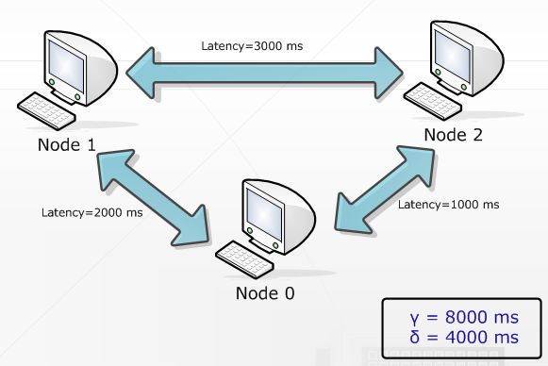

## 1.1 Experiment with Perfect Failure Detector Component